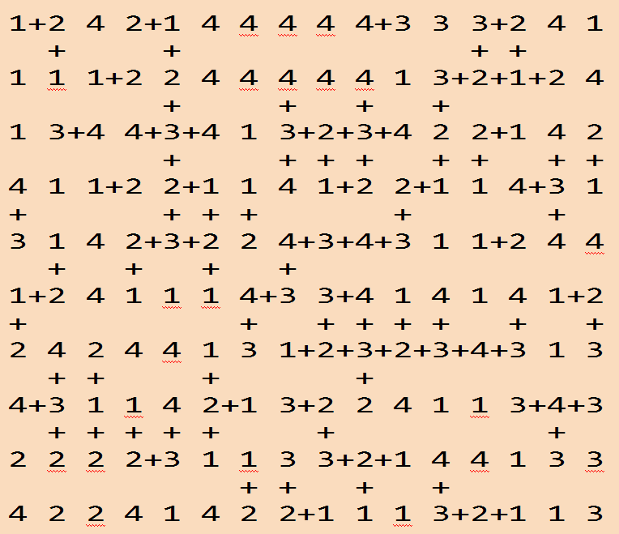

Project: Chain

The aim of the project is to develop a number game.

General Information

The game is played in a board with 10*16 area of numbers. Game elements are numbers (1-4) and plus signs. The aim of the game is reaching the highest score by constructing number chains.

Game Elements

Board
- Consist of 10*16 area of numbers

Numbers
- Number set: 1, 2, 3, 4

+
- Player constructs chains by inserting + into the suitable places.
  - Cursor keys: To move cursor on the board
  - Space: Insert/remove +
  - Enter: End of the round and calculate the chain
  - E: End of the game

Chain
- A chain is number squares joined with plus signs in 4 directions.
- Difference must be 1 between numbers of neighbor squares in the chain.

Table
- In each round, constructed chains are accumulated in the table.

Game Initialization

Number area of the board (10*16) is filled with 1, 2, 3 or 4 numbers with equal probability. Player can set the random number seed.

Game Playing Information

In each round;
- Player constructs a single chain by inserting + into the suitable places.
- Chain rules:
  - There must be only one chain in each round. Chain with more than one part, broken chains, wrong positioned plus signs are prohibited.
  - Difference between neighbor squares in the chain must be 1 (+1 or -1).
  - The number of squares in the chain must be at least 4.
  - The score of the chain is n² (n: The number of elements in the chain)
- When the chain is constructed, the player presses the enter key.
  - Then the chain is checked.
    - If the chain has errors or insufficient elements, game is over with the current score of the player.
    - If the chain is correct:
      - The chain is added to the table.
      - The chain disappears from the board.
      - The score of the chain is calculated and added to the player's score.
      - Next round starts.
Sample Game Screens

1 2 4 2 1 4 4 4 4 4 3 3 3 2 4 1 Board Seed : 4523
Round : 1
1 1 1 2 2 4 4 4 4 4 1 3 2 1 2 4 Score : 0
-----------------------------------------------------
1 3 4 4 3 4 1 3 2 3 4 2 2 1 4 2 Table:

4 1 1 2 2 1 1 4 1 2 2 1 1 4 3 1

3 1 4 2 3 2 2 4 3 4 3 1 1 2 4 4

1 2 4 1 1 1 4 3 3 4 1 4 1 4 1 2

2 4 2 4 4 1 3 1 2 3 2 3 4 3 1 3

4 3 1 1 4 2 1 3 2 2 4 1 1 3 4 3

2 2 2 2 3 1 1 3 3 2 1 4 4 1 3 3

4 2 2 4 1 4 2 2 1 1 1 3 2 1 1 3

1 2 4 2 1 4 4 4 4 4 3 3 3 2 4 1 Board Seed : 4523
Round : 1
1 1 1 2 2 4 4 4 4 4 1 3 2 1 2 4 Score : 0
-----------------------------------------------------
1 3 4 4 3 4 1 3 2 3 4 2 2 1 4 2 Table:

4 1 1 2 2 1 1 4 1 2 2 1 1 4 3 1
+
3 1 4 2 3 2 2 4+3+4+3 1 1 2 4 4
+
1 2 4 1 1 1 4+3 3 4 1 4 1 4 1 2
+
2 4 2 4 4 1 3 1 2 3 2 3 4 3 1 3

4 3 1 1 4 2 1 3 2 2 4 1 1 3 4 3

2 2 2 2 3 1 1 3 3 2 1 4 4 1 3 3

4 2 2 4 1 4 2 2 1 1 1 3 2 1 1 3

1 2 4 2 1 4 4 4 4 4 3 3 3 2 4 1 Board Seed : 4523
Round : 1
1 1 1 2 2 4 4 4 4 4 1 3 2 1 2 4 Score : 64
-----------------------------------------------------
1 3 4 4 3 4 1 3 2 3 4 2 2 1 4 2 Table:
2+3+4+3+4+3+4+3
4 1 1 2 2 1 1 4 1 2 . 1 1 4 3 1

3 1 4 2 3 2 2 . . . . 1 1 2 4 4

1 2 4 1 1 1 . . 3 4 1 4 1 4 1 2

2 4 2 4 4 1 . 1 2 3 2 3 4 3 1 3

4 3 1 1 4 2 1 3 2 2 4 1 1 3 4 3

2 2 2 2 3 1 1 3 3 2 1 4 4 1 3 3

4 2 2 4 1 4 2 2 1 1 1 3 2 1 1 3

1 2 4 2 1 4 4 4 4 4 3 3 3 2 4 1 Board Seed : 4523
Round : 2
1 1 1 2 2 4 4 4 4 4 1 3 2 1 2 4 Score : 100
-----------------------------------------------------
1 3 4 4+3 4 1 3 2 3 4 2 2 1 4 2 Table:
+ 2+3+4+3+4+3+4+3
4 1 1 2 2 1 1 4 1 2 . 1 1 4 3 1 +
+ + 4+3+2+3+2+1
3 1 4 2 3+2 2 . . . . 1 1 2 4 4

1 2 4 1 1 1 . . 3 4 1 4 1 4 1 2

2 4 2 4 4 1 . 1 2 3 2 3 4 3 1 3

4 3 1 1 4 2 1 3 2 2 4 1 1 3 4 3

2 2 2 2 3 1 1 3 3 2 1 4 4 1 3 3

4 2 2 4 1 4 2 2 1 1 1 3 2 1 1 3

1 2 4 2 1 4 4 4 4 4 3 3 3 2 4 1 Board Seed : 4523
Round : 3
1 1 1 2 2 4 4 4 4 4 1 3 2 1 2 4 Score : 125
-----------------------------------------------------
1 3 4 . . 4 1 3 2 3 4 2 2 1 4 2 Table:
2+3+4+3+4+3+4+3
4 1 1 2 . . 1 4 1 2 . 1 1 4 3 1 +
4+3+2+3+2+1
3 1 4 2 . . 2 . . . . 1 1 2 4 4 +
1+2+3+4+3
1 2 4 1 1 1 . . 3 4 1 4 1 4 1 2
+
2 4 2 4 4 1 . 1 2 3 2+3+4+3 1 3

4 3 1 1 4 2 1 3 2 2 4 1 1 3 4 3

2 2 2 2 3 1 1 3 3 2 1 4 4 1 3 3

4 2 2 4 1 4 2 2 1 1 1 3 2 1 1 3

1 2 4 2 1 4 4 4 4 4 3 3 3+2+4 1 Board Seed : 4523
+ Round : 4
1 1 1 2 2 4 4 4 4 4 1 3 2+1 2 4 Score : 125
-----------------------------------------------------
1 3 4 . . 4 1 3 2 3 4 2 2 1 4 2 Table:
2+3+4+3+4+3+4+3
4 1 1 2 . . 1 4 1 2 . 1 1 4 3 1 +
4+3+2+3+2+1
3 1 4 2 . . 2 . . . . 1 1 2 4 4 +
1+2+3+4+3
1 2 4 1 1 1 . . 3 4 . 4 1 4 1 2

2 4 2 4 4 1 . 1 2 3 . . . . 1 3

4 3 1 1 4 2 1 3 2 2 4 1 1 3 4 3

2 2 2 2 3 1 1 3 3 2 1 4 4 1 3 3 Error in chain
- Game Over -
4 2 2 4 1 4 2 2 1 1 1 3 2 1 1 3

End of the Game and High Score Table

Player can exit the game by pressing the E key.

After the game finishes, High Score Table is displayed in descending order.
Default High Score Table for the game (in the following order in "highscore.txt" file):
- Sema Fırat 200
- Tarık Deniz 525
- Ali Vadi 16
- Seda Rüzgar 90

Structures

Board : 2D Array
Chain : Singly Linked List (SLL)
Table : Multi Linked List (MLL)
High Score Table : Doubly Linked List (DLL)

